**A0100 - ANALYSIS REPORT**

.

.

.

.

.

.

.

.

.

.

.

.

.

.

.

.

|  |  |
| --- | --- |
| **Version:** | **1.2** |
| **Status:** | Draft |
| **Approver:** |  |
| **Author:** | Quách Hoàng Minh  Nguyễn Bảo Nguyên  Ngô Gia Hân  Nguyễn Vũ Anh Thư |



**Document history**

|  |  |  |  |  |
| --- | --- | --- | --- | --- |
| Version | Date | Author | Status | Remarks |
| 1.0 | 30-11-2021 | Quách Hoàng Minh  Nguyễn Bảo Nguyên  Ngô Gia Hân  Nguyễn Vũ Anh Thư | Draft |  |
| 1.1 | 23/12/2021 | Quách Hoàng Minh  Nguyễn Bảo Nguyên  Ngô Gia Hân  Nguyễn Vũ Anh Thư | Draft | Update section 2 |
| 1.2 | 31/12/2021 | Quách Hoàng Minh  Nguyễn Bảo Nguyên  Ngô Gia Hân  Nguyễn Vũ Anh Thư | Draft | Add section algorithm and roadmap |
|  |  |  |  |  |

**References**

|  |  |  |  |
| --- | --- | --- | --- |
| Reference | Title | Author | Version |
|  |  |  |  |

Table of contents

1. Introduction 4

1.1 Purpose 4

1.2 Glossary 5

2. Context 6

2.1. Business opportunities 6

2.2. Vision 6

2.3. Benefit analysis 6

2.4. Requirements 7

2.5. Functional epics solution 9

2.5.1. Login 9

2.5.2. View Home Page 10

2.5.3. Search Index 10

2.5.4. Favourite Lists 11

2.5.5. View Specific Stock 13

2.5.6. Compare stocks 15

2.5.7. View Stock Price 17

2.5.8. Reminder List 17

2.5.9. User Profile 19

2.6. Scope 19

2.7. Outside scope 19

2.8. Approval Criteria 20

2.9. Technical Analysis 21

2.10. Algorithm 21

2.10.1. How it works 21

❖ Linear Regression 22

❖ Support Vector Machine (SVM) 22

❖ Long Short-term Memory (LSTM) 2

2.10.2. Results 2

2.10.3. Comparison 5

2.10.4. Conclusion 6

2.11. Roadmap 6

3. References 7

# Introduction

## Purpose

This documentation aims to record the agreement and decisions between customer and development team. In this analysis process, we would like to achieve the expectation between the team and the client about customers’ requirement’s solution.

This report serves as a consolidation of Trading Vision Project (TVP) original requirements, the development team's proposal and the dialogue about every single requirement and acceptance criteria throughout the project timeline.

The document is used as a reference for developing a more detailed specification and project plan in the O0500 deliverables. In the clarification phase multiple project deliverables are to be delivered. In the clarification report the deliverables listed below are embedded either as isolated sections or in their relevant context, e.g., the User Interface Prototype deliverable is split across relevant functional descriptions, while the High-level Software Architecture deliverable has its own dedicated section.

The document is prerequisite for these documents

* A0140 - Functional Epics
* A0150 - User Interface Prototype
* O0500 - High-level Software Architecture
* P0100 - Project Roadmap

## Glossary

|  |  |
| --- | --- |
| **Candlestick Chart** | Candlestick Chart used by traders to determine possible price movement based on past patterns, it shows four price points (open, close, high, and low) throughout the period the trader specified |
| **HOSE** | Ho Chi Minh Stock Exchange was formerly known as HCM Securities Trading Centre, established in 1998 under Decision No. 127/1998/QD-TTg of the Prime Minister |
| **HNX** | Hanoi Stock Exchange, formerly the Hanoi Securities Trading Centre located in Hanoi, Vietnam, was launched in March 2005 and handles auctions and trading of stocks and bonds. |
| **UPCOM** | UPCOM (Unlisted Public Company Market) is the market at HNX for public companies not yet listed and was launched in June 2009 with 10 initial companies |
| **Highest Price** | Highest Price is the highest price exchanged in a session. |
| **Lowest Price** | Lowest Price is the lowest price exchanged in a session. |
| **Price Floor** | Price Floor is the lowest level at which an investor can place an order to buy or sell securities during the trading day |
| **Price Ceiling** | Price Ceiling is the highest price at which an investor can place an order to buy or sell securities during the trading day. |
| **Matching Order Price** | Matching Order Price is the process by which a securities exchange pairs one or more unsolicited buy orders to one or more sell orders to make trades. |
| **Reference Price** | Reference Price is the closing price at the previous most recent trading session. The reference price is taken as the basis for calculating the trading range of stocks in the session |
| **Session** | A trading session is a certain period in the stock market, at which time transactions and orders to buy and sell stocks will take place. |
| **Volume** | Volumes measure the number of shares traded in a stock or contracts traded in futures or options. |
| **Stock Symbol** | Stock Symbol is a unique series of letters assigned to a security for trading purposes. |
| **LSTM** | Long short-term memory |
| **SVM** | Support Vector Machine |
| **MAPE** | Mean absolute percentage error |

# Context

The customer has a budget, and they want to invest in the stock market. They want to know the information of many stocks, so that they can decide which stock to invest in.

## Business opportunities

Netcompany has a group of investors that wants to have a website to check the stock market’s information. For convenience in grasping market trends, customers want an application to view the stock market price and provide reliable news about the stock market. The website should also give the auto technology prediction in the coming week (5 days) without hiring stock forecasters. However, this will be a difficult problem for software developers because the stock market is complex and has many different price ranges. In addition, the stock price is always changing, and it fluctuates continuously from time to time.

The stock market is a volatile place. The cause of that fluctuation comes from many sources: market trends, investor sentiment, company's financial statements, etc. There are two ways to analyse securities: Fundamental analysis and technical analysis.

Fundamental analysis assumes that stock prices do not inevitably reflect the true intrinsic value of the underlying business and our solution for our customers lies in the second analytical method. Technical analysis generally assumes that a stock's price reflects all available information and that prices generally move according to trends. In other words, by analysing a stock's price history, you may be able to predict its future price behaviour. If you have ever seen someone trying to identify patterns in stock charts or discussing moving averages, that's a form of technical analysis (Frankel, 2021). As a result, we will use technical analysis as the main method in this project.

## Vision

When the project is completed, a stock market web application is delivered to the client. Customers can view stock price trends on HOSE, HNX and UPCOM stock exchanges. In addition, customers can use the predict function to predict prices in the next one week.

## Benefit analysis

Customers have capital and want to invest in stocks but are still confused because there are too many information sources. With this web application, customers will be able to easily track information about stocks on stock exchanges in Vietnam, and visually monitor chart, line, and column charts. In addition, customers can use the predict function as a source of reference, increasing their confidence in their investment.

## Requirements

|  |  |  |
| --- | --- | --- |
| **ID** | **Feature** | **Description** |
| 1 | Login/Logout | As a customer, I'm able to login/logout |
| 2 | Overview page | As a customer, after logged in successfully, I'm able to see the overview page:  + I can see the search button for search index        + I can see the list of capitalization-weighted indexes of all companies listed on the stock exchange and their values (date, point, volume)). E.g.: (these indices are just an example. We will choose them depend on what dataset we can find)              + VNIndex of HoSE              + VN30              + HNX-Index              + HNX30-Index              + UPCOM        + Favourite indices list:                + If it is unavailable, display empty                 + I can see the information of each stock index                           + date, price, volume                           + I can click the index to view the chart |
| 3 | Search index | As a customer, I'm able to search index  + I can search by index  + I can add index search result to favourite list  + I can click the index search result to view its chart |
| 4 | Index chart | As a customer, I'm able to view index chart:    + I can see the list of charts that I would like to view. They are line chart (by default) & candlestick chart    + I can view the index chart:             + line chart:                     + x-axis: time unit (date or month)                      + y-axis: price (VND)                   + prediction area                             + When I hover to the line, I can see the popup which will display a price      + I can choose to candlestick chart to view index      + I can see the bar chart which will display the volume of index by time unit in the bottom       + I can see the prediction volume area      + When I hover to the column, I can see the popup which will display a price      + I can do comparison by choosing other indices       + In the current chart, I can see one more line chart of the comparing index. |
| 5 | Prediction Index | Display prediction to the index chart |
| 6 | Setting reminder | As a customer, I can set reminder:  + I can choose the expectation point in the prediction area in a chart  + I can create reminders by adding titles, timing, and content.  + I can receive the reminder via email. |
| 7 | Manage user profile | As a customer, I'm able to view my profile:     + I can view my name from Facebook or Gmail  As a customer, I want to delete all of personal information and related actions when I do not continue using the system. |

## Functional epics solution

In this section, we will provide a prototype of the website, which will include these pages’ prototype: Homepage, Login. View stock price, view specific stock, favourite list, and reminder list. These prototypes will also have the descriptions of the pages and some basic information about the function that have on each page.

### Login

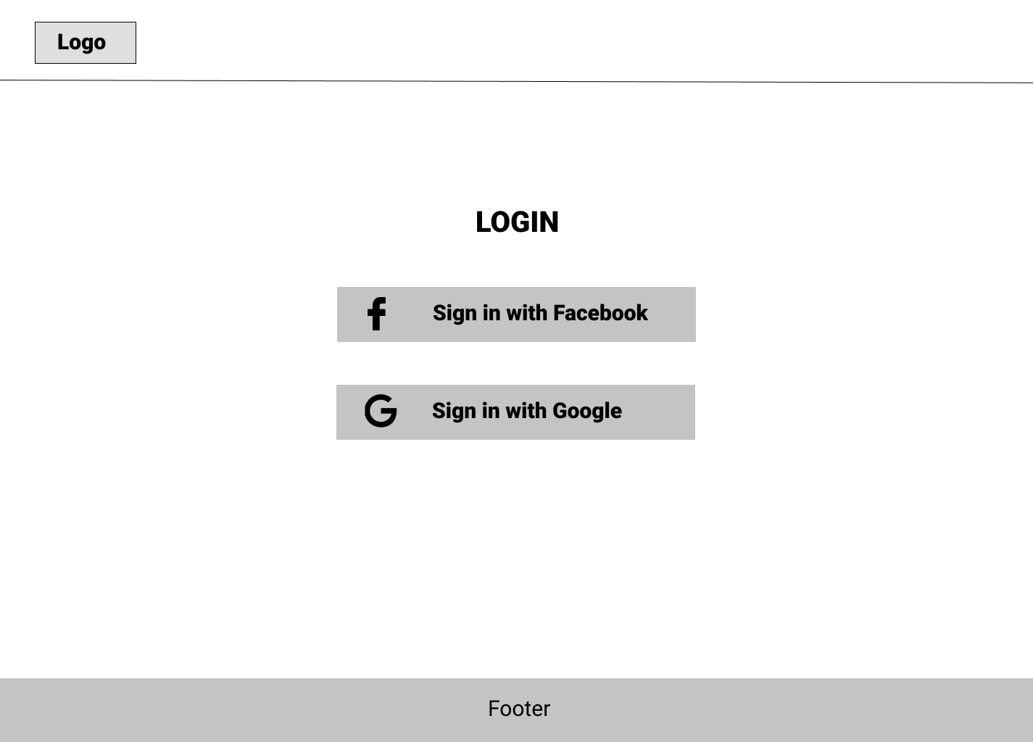

Figure : Login page

The login page will provide for users two ways to login to the page: Facebook or Google. If the user chooses to log in, a pop up will appear and this navigates the user to the login page of google or Facebook. The user will log in to this page.

### View Home Page

Figure : Homepage

This is the homepage of the website; users can see the label and the company name including the chart of 5 stocks that are trending and have high volume on that day. We could search the index in the search bar on the header. The banner will show a wallpaper related to stock. There is a search function on the top right for the user to input the name of the index that they want to find.

### Search Index

When users click on the search bar, a popup will be displayed. Users can see all stocks belonging to each stock exchange or can write exact stock symbols to find. All stocks are always displayed in alphabetical order.

Figure : Search Index

### Favourite Lists

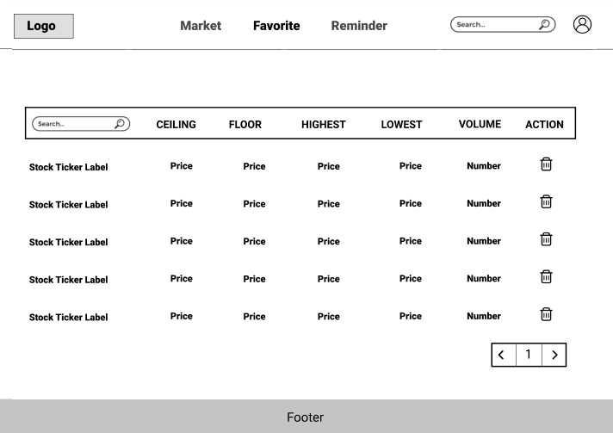

Figure : Favourite list

The favourite page, this page displays all the stock, which the user follows. It will have the search bar for searching the stock favourite and the information of all the stock users added to this list. These stocks also show the information including ceiling price, floor price, highest price, lowest price, volume. In case, user does not have any favourite stock, there is a message “**Add your favourite stock**”

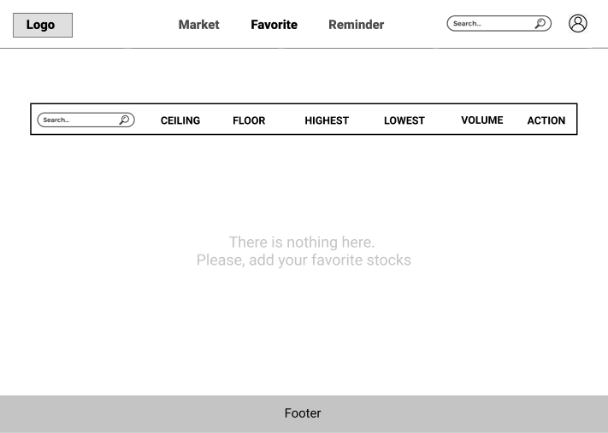

Figure : There is no stock in favourite list

Users can click the “**Bin**” icon to remove a stock from the Favourite List.

### View Specific Stock

Figure : Specific Stock

This is the stock detailed page, which will contain the stock’s sticker label and the detailed information of each stock. This will contain the name of the company, field, link to a webpage, a short description of the company, and some financial numbers. Also, this page will show the user the specific chart of that stock. These charts could be chosen to show a line graph or candlestick chart. On this page, the line chart also shows the prediction of stock trends predicted by a selected algorithm. The graph showing the prediction will be colored differently from the actual line.

Users also can view candlestick charts by clicking on “**Candlestick chart”**.

Figure : Candlestick chart

In order to add a stock to Favorite list, users can click on the “**Heart**” icon, then the information of that stock will be added into the Favorite page.

Users can click the “**Add**” icon to add reminders on the prediction line. They also can hover at any point on the line chart to view specific date and price.

Figure : Before and After adding favourite list.

Figure : User also can hide the company information.

### Compare stocks

When the Compare button is clicked, this popup will show up. You can search like what you do in the search function.

Figure : Choose appropriate stock to compare.

Then, you can choose which stock you want to compare with. There will exist two-line charts, each of them will have different colours for the actual part and prediction part. If you want to close the compare function, click the Compare button again, and choose the stock that you chose before one more time.

Figure : Compare two stocks

Figure : Click "Tick" icon to turn off comparison

### View Stock Price

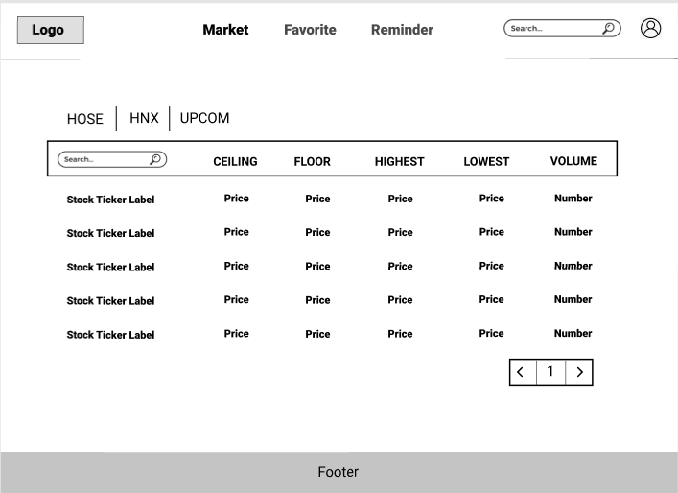

Figure : View Stock Page

This is the market page which will have the navigator header contain page navigation and search stock bar like the other page. In the main content, there will be a tab for users to choose their exchange market. Their option could be UPCOM, HNX or HOSE, for each exchange, there will be a list of stocks which include the information about ceiling, floor, highest, lowest and volume of every stock. Also, this will include a search bar for customer search for the ticket of stock they want to find.

### Reminder List

Figure : Reminder list

The final wireframe design will be the reminder page. This page will contain the reminder that users have set before with the detailed time they want to notify and the stock or content in each reminder. Users could also edit or remove the reminders in this page.

When users click “**Add**” button, a popup will be displayed to add reminder. Users can click on the “Plus” icon in order to add their own reminder.

Figure : A popup to add reminder

In case, user does not have any reminder, a message “**Add your reminder**” will be displayed. Users can click on the “Plus” icon in order to add their own reminder.

Figure : There is no reminder in the reminder list

### User Profile

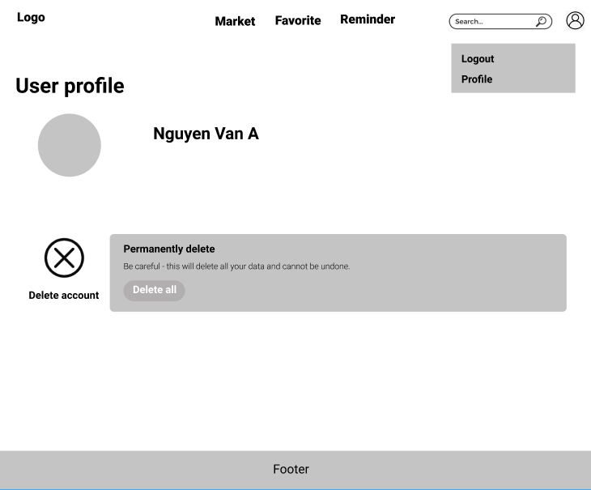

Figure : User Profile page

Users can use the dropdown menu from their account icon in the header to logout or access to the profile and delete account. This is the page for users to manage their account. Users can choose to delete all if they want to delete all information of users on the website.

### Scope

* Costs must not exceed the estimated budget.
* The final product must be released within 6 months.
* Must have a UAT version for customers to try before releasing the final version.
* The final product must satisfy the Minimum Viable Product (MVP).
* There are documents and resources that prove the predictions are reliable.

### Outside scope

Below features are not included in this project:

* Allow users to directly buy stocks on the website
* Have a box chat between all users of the page
* Have an admin page.
* Support real-time stock information

### Approval Criteria

* Web app that shows charts representing stock market prices as well as with the table of the stock information.
* The algorithm can predict about 55-60% correctly.
* Successfully deploying web apps and functions to web browsers.
* Price chart viewing, and price prediction functions can work well.
* Have an account to meet the account protection requirement of users.
* It is possible to switch back and forth between different types of shares

### Technical Analysis

Figure : Data Flow from being fetched to train and display

System gets data from two sources: CafeF for stock price and VCBS for company information. The retrieved data will be mapped to the database of system MongoDB in suitable schema. After that, those data will be pre-processed to prepare for the prediction phase afterwards. Finally, on the monitor of the users shows the chart according to the output of the prediction.

### Algorithm

Our problem is to predict stock trends in the upcoming week. After doing research, we have found some algorithms; however, we selected three algorithms suggested to solve our problem:

* **Long short-term memory (LSTM):** The Long Short-Term Memory is an extended version of Recurrent Neural Network (RNN). While RNN is well-known in solving sequential data problems, its structure is still simple so the ability to connect layers over a large distance is not good. Basically, it could not remember information of far data, so the first elements of input normally do not have much effect on the output prediction. The reason for this is the RNN effect by vanishing gradient. To solve the problem of RNN, LSTM was designed to work by remembering the related information that is important for the prediction and removing all the other data (Brownlee, 2021).
* **Support Vector Machine (SVM)**: Support Vector Machine (SVM) is an algorithm belonging to the Supervised Learning group and used in classification as well as regression. This algorithm will try to maximize the margin to find the best hyperplane and divide data, the data points in two boundaries is called support ᴠeᴄtor because we could use them to support finding hyperplane (Stecanella, 2017).
* **Linear Regression**: Linear regression uses the relationship between the data-points to draw a straight line through all of them. This line can be used to predict future values. Regression analysis is a statistical methodology that allows us to determine the strength and relationship of two variables. Regression is not limited to two variables; we could have 2 or more variables showing a relationship. The results from the regression help in predicting an unknown value depending on the relationship with the predicting variables. When there is a single input variable, the regression is referred to as Simple Linear Regression. We use the single variable (independent) to model a linear relationship with the target variable (dependent). We do this by fitting a model to describe the relationship (Wong, 2020).

### How it works

In this section, we describe in detail about how each algorithm works to produce the results.

#### Linear Regression

Figure : Linear Regression. (Source: [Data science blog](https://www.reneshbedre.com/blog/linear-regression.html))

Linear Regression is the process of finding a line that best fits the actual data points on the plot, so that we can use it to predict output values for inputs that are not present in the data set we have, with the belief that those outputs would fall on the line. Performance (and error rates) depends on various factors including how clean and consistent the data is. There are different ways of improving the performance (i.e., generalizability) of the model (AI-Masri, 2019). Read more at this article[1].

#### Support Vector Machine (SVM)

SVM categorizes data points by mapping them to a high-dimensional feature space, even when the data is not otherwise linearly separable. After identifying a separator between the categories, the data are transformed so that the separator can be drawn as a hyperplane. Following that, new data features can be utilized to determine which category a new record should belong to (How SVM Works, n.d.).

Figure : Transformed data

For example, consider the above figure 20, in which the data points fall into two different categories. The two categories can be separated with a curve, as shown in the following figure 21. After the transformation, the boundary between the two categories can be defined by a hyperplane, as shown in the following figure 22.

The mathematical function used for the transformation is known as the kernel function. There are various types of kernel functions for SVM: Linear, Polynomial, Radial basis function (RBF), and Sigmoid. A linear kernel function is recommended when linear separation of the data is straightforward. In other cases, one of the other functions should be used. You will need to experiment with the different functions to obtain the best model in each case, as they each use different algorithms and parameters. For more information on this algorithm, this page[2] *ADVANCED REGRESSION AND PREDICTION: MACHINE LEARNING TOOLS* by *Ilán F. Carretero Juchnowicz* would help you.

#### Long Short-term Memory (LSTM)

Figure : LSTM layers. (Source: [Research Gate](https://www.researchgate.net/figure/Structure-of-the-LSTM-based-classifier_fig1_325702200))

The input will be connected through the LSTM unit and then produce the output H. H is then connected to a dense layer activated by the rectified linear units (ReLU). The dense layer is then connected to another dense layer with two neurons activated by the logistic units, which is employed to give predicted value.

After analysing in detail and applying those three algorithms to the found dataset[3], we have the following results and comparison.

### Results

When the size of the data is large (like VNM), it shows that the MAPE is smaller (1.35 and 0.6). Moreover, because our LSTM algorithm’s performance significantly decreases when forecasting more than 1 week, so our scope for predicting stock’s price is only 5 days.

Figure 24: ACB 5 days predicting

Figure 25: VNM 5 days predicting

Figure 26: ACB 15 days predicting

Figure 27:: VNM 15 days predicting

After finding some methods for evaluating the performance of algorithms, we decided to use **mean absolute percentage error (MAPE)** (Wen, 2020). MAPE means the percentage of difference between predicted values and actual values. For example, the MAPE value of 11.5% means that the average difference between the predicted value and the actual value is 11.5%. The lower the value for MAPE, the better a model can predict values. For example, a model with a MAPE of 5% is more accurate than a model with a MAPE of 10%.

Applying other two algorithms to the same dataset, we obtained this table below:

Table : Comparison MAPE between three algorithms

|  |  |  |  |  |
| --- | --- | --- | --- | --- |
|  | **ACB**  **(5 days) (%)** | **ACB**  **(15 days) (%)** | **VNM**  **(5 days) (%)** | **VNM**  **(15 days) (%)** |
| **LSTM** | 1.35 | 2.87 | 0.6 | 1.42 |
| **SVM** | 3.15 | 3.60 | 19.18 | 11.70 |
| **Linear Regression** | 1.96 | 2.35 | 10.64 | 10.40 |

From table 2, we can see clearly that LSTM has the minimum MAPE for both ACB[4] and VNM[5]. With a longer time of predicting, the MAPE also increases significantly. That is the reason we only use the algorithm to predict the next five days.

### Comparison

Table : Comparison between three algorithms

|  |  |  |  |
| --- | --- | --- | --- |
|  | **LSTM** | **SVM** | **Linear Regression** |
| Input | Close price | Close price | Close Price |
| Output | Predicted price | Predicted price | Predicted price |
| Process any length of input | Check |  |  |
| Have unchanged model size | Check |  |  |
| Memory efficient |  | Check | Check |
| Remember and forget selective data | Check |  |  |
| Prone to outliers |  | Check | Check |
| Prone to overfitting | Check |  |  |
| Prone to underfitting |  | Check | Check |

Based on the table above, it can be shown that LSTM algorithms slightly prove it as a promising solution.

### Conclusion

After evaluating LSTM, Linear Regression and SVM, it is evident that LSTM gives the best performance among the three algorithms (lowest MAPE). For linear Regression, it can be prone to regime shift in the financial industry (Zhichao Zou, Zihao Qu, 2020). For SVM, LSTM outperforms SVM in general due to its ability to learn selectively and can remember or forget the required historical data (Sai Krishna Lakshminarayanan, John McCrae, 2019). In conclusion, because of its advantages, the LSTM algorithm will be chosen and applied for predicting stock price in the project.

### Roadmap

The project roadmap is established based on priorities of functionality from TVP. The roadmap is still high-level but has placed each theme of functionality into a release.

As established in Project Dependencies, the project is constrained by several dependencies, which is handled by scheduling functionality with dependencies in releases where time permits completion of the dependencies. Due to this, some functionality is planned later than their original priority would demand, in order to accommodate for the dependency. All project and system dependencies have been marked as milestones:

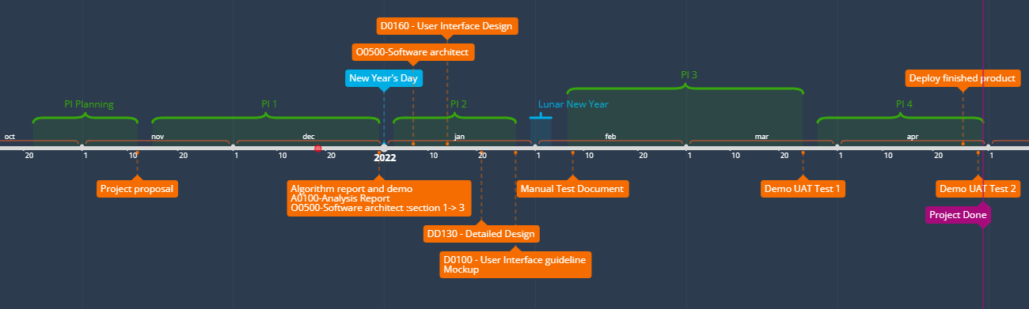

Figure28: Roadmap

The result is the following releases:

* **Release 1**: Demo for UAT test 1
* **Release 2**: Finish product
* **Release 3:** Demo for UAT test 2

# References

AI-Masri, A. (2019, Mar 19). *How Does Linear Regression Actually Work?* Retrieved from Towards Data Science: https://towardsdatascience.com/how-does-linear-regression-actually-work-3297021970dd

Brownlee, J. (2021, Jul 7). *A Gentle Introduction to Long Short-Term Memory Networks by the Experts*. Retrieved from Machine Learning Mastery: https://machinelearningmastery.com/gentle-introduction-long-short-term-memory-networks-experts/

*How SVM Works*. (n.d.). Retrieved from IBM: https://www.ibm.com/docs/en/spss-modeler/SaaS?topic=models-how-svm-works

Juchnowicz, I. F. (n.d.). *Support Vector Machines (SVM).* Retrieved from Bookdown.org: https://bookdown.org/f100441618/bookdown-regresion/ml-tools.html#support-vector-machines-svm

Sai Krishna Lakshminarayanan, John McCrae. (2019). *A Comparative Study of SVM and LSTM Deep Learning.* Retrieved from http://ceur-ws.org/Vol-2563/aics_41.pdf

Stecanella, B. (2017, Jun 22). *Support Vector Machines (SVM) Algorithm Explained*. Retrieved from MonkeyLearn: https://monkeylearn.com/blog/introduction-to-support-vector-machines-svm/

Wen, Y. (2020). *Research of Stock Price Prediction Based on.* Retrieved from IOP Conference Series: https://iopscience.iop.org/article/10.1088/1757-899X/790/1/012109/pdf

Wong, J. (2020, Nov 29). *Linear Regression Explained*. Retrieved from Towards Data Science: https://towardsdatascience.com/linear-regression-explained-1b36f97b7572

Zhichao Zou, Zihao Qu. (2020). *Using LSTM in Stock prediction and Quantitative.* Retrieved from CS230 - Stanford: http://cs230.stanford.edu/projects_winter_2020/reports/32066186.pdf

1. AI-Masri, A. (2019, Mar 19). How Does Linear Regression Actually Work?

   Retrieved from Towards Data Science: https://towardsdatascience.com/how-does-linear-regression-actually-work-3297021970dd
2. Juchnowicz, I. F. (n.d.). Support Vector Machines (SVM).

   Retrieved from Bookdown.org: https://bookdown.org/f100441618/bookdown-regresion/ml-tools.html#support-vector-machines-svm
3. Dataset was retrieved from CafeF on December 10th,2021. This dataset includes all three Vietnamese stock exchanges and their respective stocks from the first days.
4. In our resource, we have ACB data on HOSE market from 14/12/2020
5. In our resource, we have VNM data on HOSE market from 14/12/2020